**Test Plan Document** By Anthony Perisco and Carter Cook

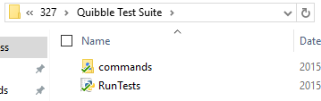

Tests sorted by the command they exercise. RunTests.py is the main executable for testing. It prompts the tester for the subfolders they wish to test. The tester enters “\commands” for all tests, “\commands\add” as an example of a particular set of tests, and “\commands\add\add as sales” as an example of a specific test.

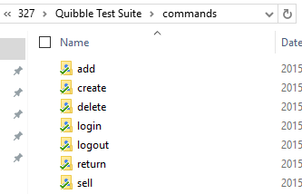

Tests are organized by their relevant command.

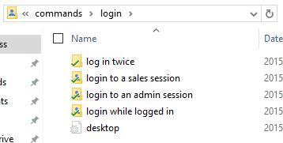

Each test case has its own folder.

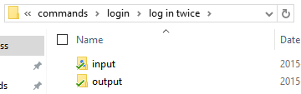

Each folder contains both inputs and outputs for the test.

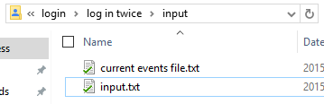

The input folder contains the starting input and current events file.

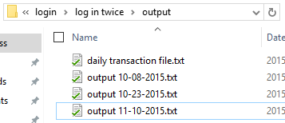

The output folder contains the expected and actual output from the program.